StayFit

Software Requirements Specification

1.0.0

February, 2022

Andon Raychev

1601261084

Lead Software Engineer

Prepared for

WSU-TC CptS 322—Software Engineering Principles I

Instructor: A. David McKinnon, Ph.D.

Spring 2005

# Revision History

|  |  |  |  |
| --- | --- | --- | --- |
| **Date** | **Description** | **Author** | **Comments** |
| <date> | <Version 1> | <Your Name> | <First Revision> |
|  |  |  |  |
|  |  |  |  |
|  |  |  |  |

# Document Approval

The following Software Requirements Specification has been accepted and approved by the following:

|  |  |  |  |
| --- | --- | --- | --- |
| **Signature** | **Printed Name** | **Title** | **Date** |
|  | <Your Name> | Lead Software Eng. |  |
|  | A. David McKinnon | Instructor, CptS 322 |  |
|  |  |  |  |

Revision History 3

Document Approval 4

1. Introduction 5

1.1 Purpose 6

1.2 Scope 6

1.3 Definitions, Acronyms, and Abbreviations 6

1.4 References 6

1.5 Overview 7

2. General Description 7

2.1 Product Functions 7

2.3 User Characteristics 18

2.4 General Constraints 19

2.5 Assumptions and Dependencies 19

3. Specific Requirements 19

3.1 External Interface Requirements 19

3.1.1 Hardware Interfaces 19

A. Appendices 19

# 1. Introduction

The introduction to the Software Requirement Specification (SRS) document should provide an overview of the complete SRS document. While writing this document please remember that this document should contain all of the information needed by a software engineer to adequately design and implement the software product described by the requirements listed in this document. (Note: the following subsection annotates are largely taken from the IEEE Guide to SRS).

## 1.1 Purpose

The purpose of this SRS document is to present a description of the software for sport activities such as running, walking and cycling and many more. It will explain what the application will do and how will it operate. This document is intended for the stakeholders and the developers of the system.

## 1.2 Scope

This software will be a helping tool for athletes and people who like sport activities. It will be designed to help them to track, save and share their activity with other people. It will be designed like a social media, giving opportunities for people to connect to other people, organize group activities, share their experience and keep track of their own progress and take challenges to complete. They can record their activity, keep track of their pace, distance and time. There will be an option for the software to connect to a smartwatch for a better overview of the statistics of the activity.

## 1.3 Definitions, Acronyms, and Abbreviations

|  |  |
| --- | --- |
| **Term** | **Definition** |
| Activity | The sport that the user has selected. It can be running, walking, cycling, hiking, canoe and ski. |
| Challenge | There will be a set of challenges for the users to complete if they wish to join. They can be to run a total of 100km, ride a bike for 400 kilometers and many others. Challenges have a limited time to complete. When the user completes the challenge, it goes to his completed challenges section in his profile. |
| Record | The user can record his activity. Recording keeps track of the distance, time, average pace heartbeat (if only shows the user has connected a smart watch). |
| Database | Collection of all the information monitored by this system. |

## 1.4 References

IEEE. IEEE Std 830-1998 IEEE Recommended Practice for Software RequirementsSpecifications. IEEE Computer Society, 1998.

## 1.5 Overview

This document gives overview of the functionality of the application, the dependencies that it will need to function and the tools for its development.

# 2. General Description

## 2.1 Product Functions

When the user launches the application for the first time, he will be greeted with the login/register page. He is given the options to login with Google, Facebook or with a StayFit account. If he is already a member, he can login with his existing StayFit account.

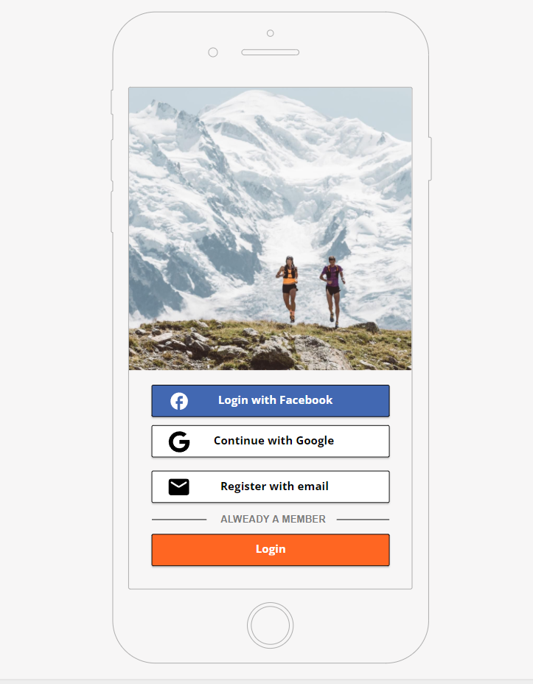

When the user successfully logs in or creates his account, he will be redirected to the home page. Here he can see his own completed activities, or those of the people he follows.

On the header there are is button for Notifications and one for searching for people.

On the footer, there are buttons for the Home, Groups, Record, Settings and his personal profile page.

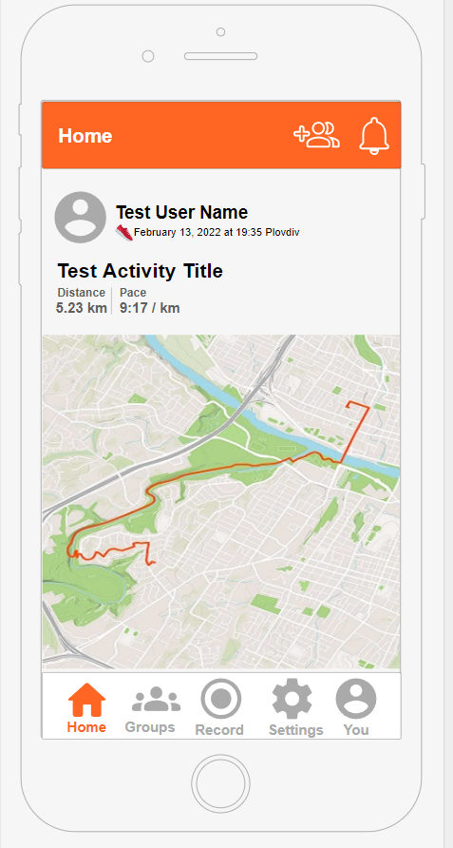

If the user presses the record activity button, he will be redirected to the Activity Preview page. Here he can see his current location on the map. On the footer, there are buttons for selecting the activity he wishes to perform, a start button and a heartbeat button

When the page opens a popup message will appear based of the internet connection signal. The popup will disappear after a few seconds.

Green – GPS SIGNAL AQUIRED – There is a stable internet connection.

ORANGE – WEAK GPS SIGNAL – The internet connection is not stable.

RED – NO GPS SIGNAL – There is no connection to the internet, or the user must allow the application to detect his current location.

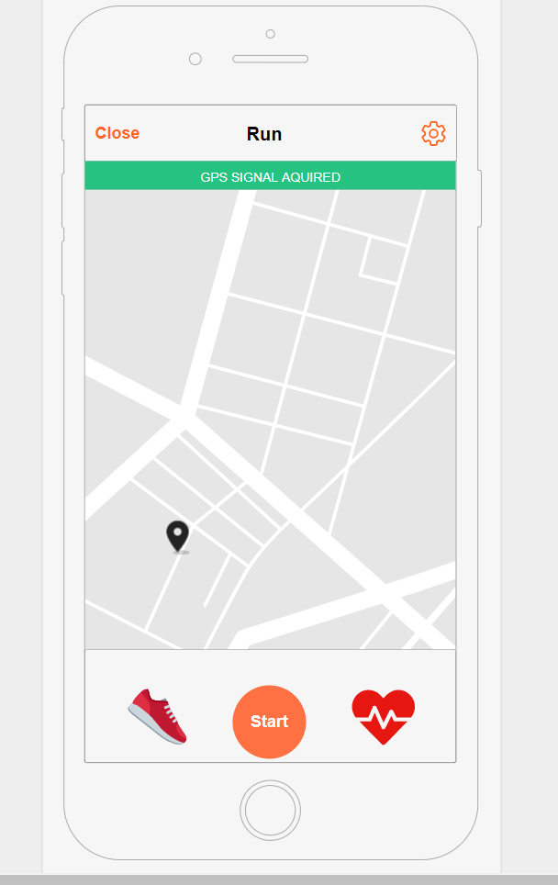

When the left button is clicked, the user can choose his current sport. Run, Ride, Walk, Hike, Canoe or Ski.

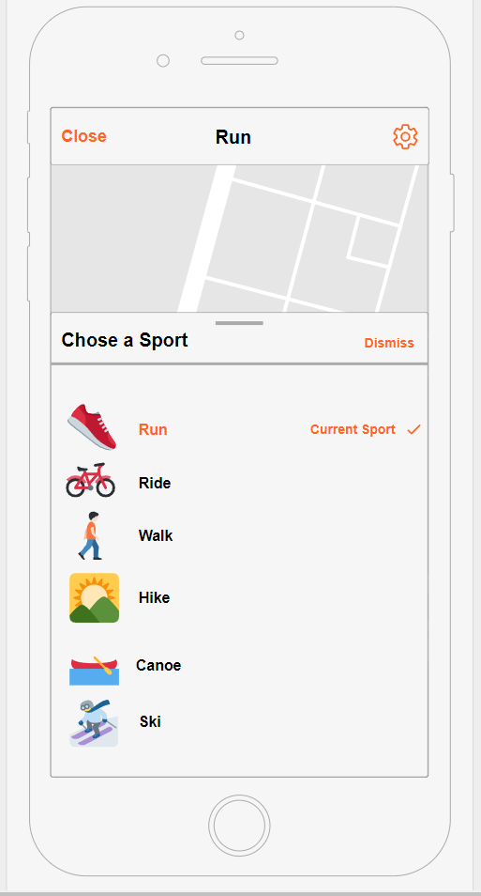

When the activity is started the user will be redirected to the Activity Started Page. Here he can keep track of his time, average pace and distance. The athlete can stop the activity or view his location on the map and his current path.

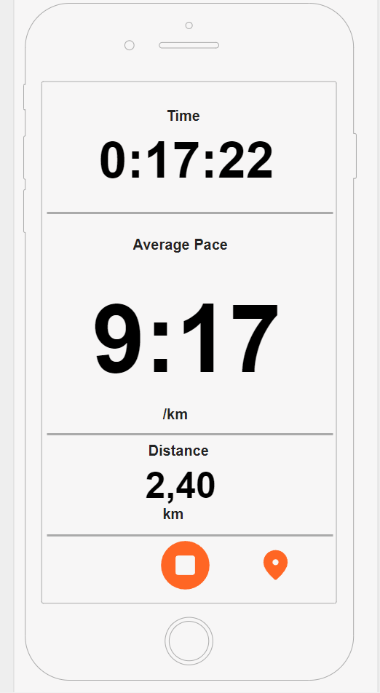

When the activity is stopped, the athlete will be presented with the information of the path, time distance and average pace. He may choose to resume the activity or finish it.

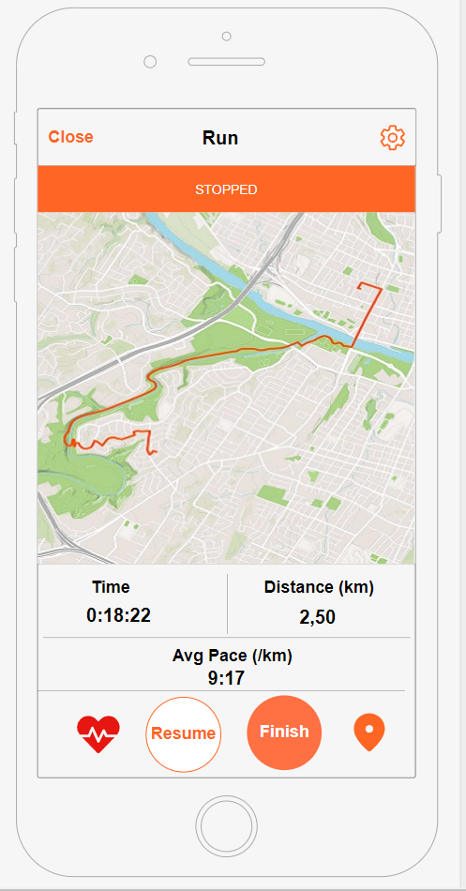

When the user decides to finish the activity, he will be redirected to the Save Activity page. Here he can choose a title, add description and change the sport. If he wishes he can upload images. The athlete can fill additional details and choose the Visibility of his activity. There is also a Discard Activity button.

When the activity is saved, the user will be redirected to the home screen, when the newly added activity is shown on his feed.

.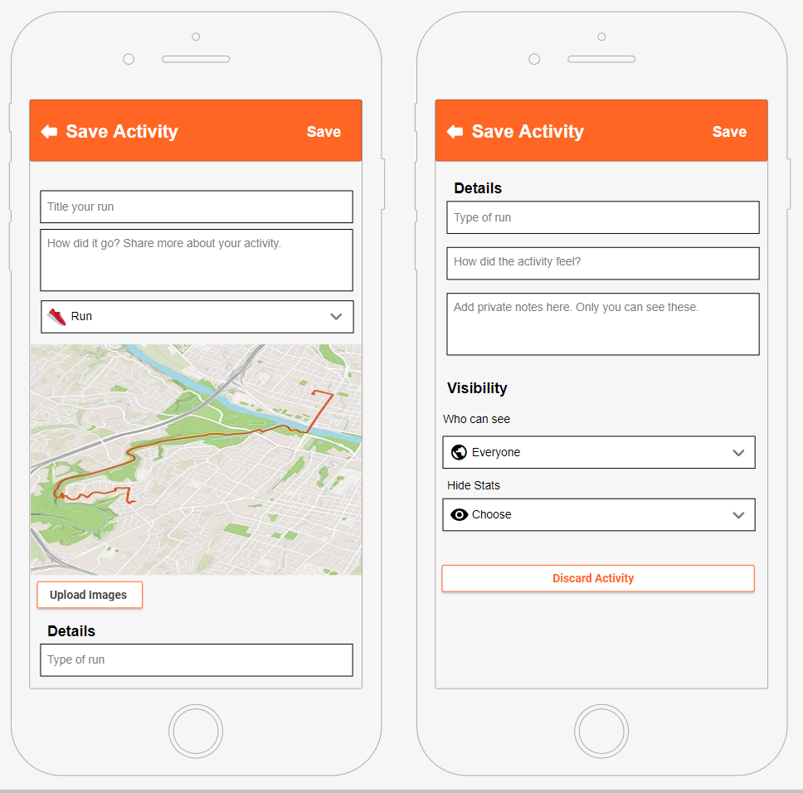

This is the groups page. Here are Three tabs. Active, Challenges, and Clubs. On the Active page, the user can see the groups and challenges he is currently participating in.

The current selected tab on this image below is the Clubs. The athlete is presented with the most popular clubs that are near his location.

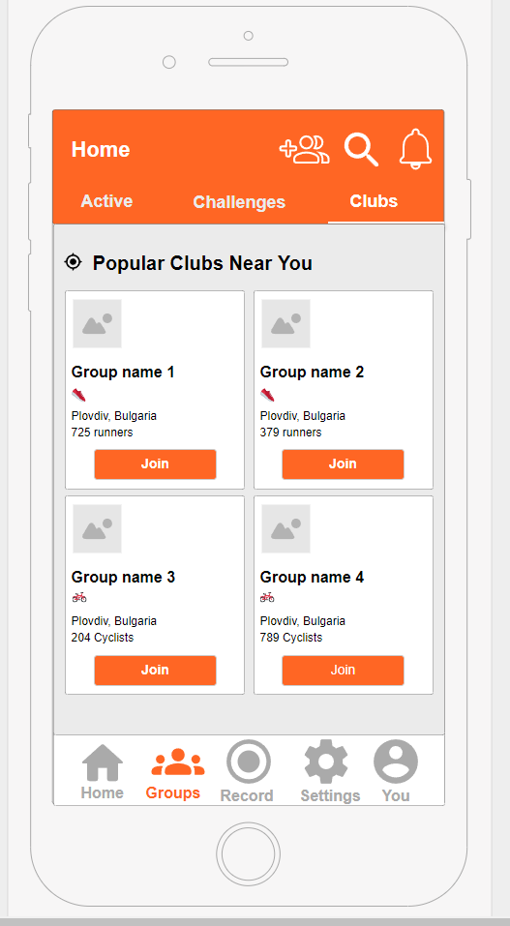

The challenges page. Here the user can join different challenges and sort them by activity with the buttons above.

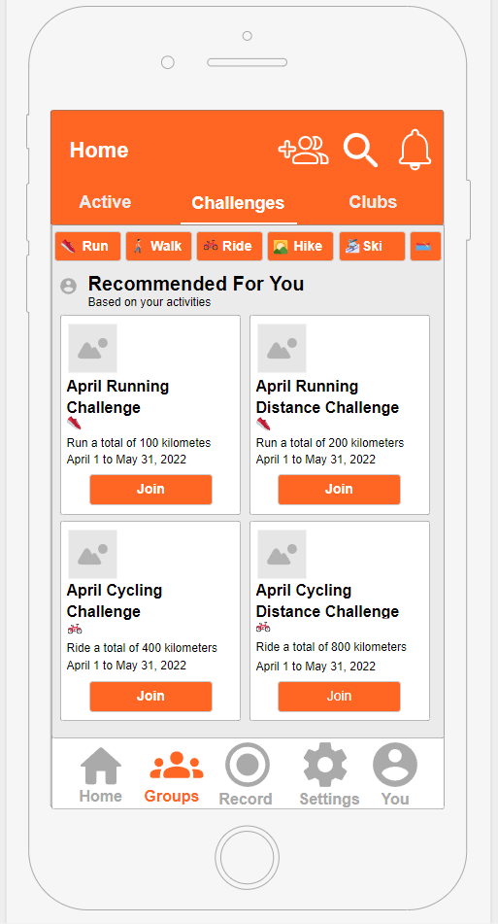

## 2.3 User Characteristics

The User us expected to be able to work with smartphones, have internet connection with an active GPS. A smartwatch is optional, but not required.

## 2.4 General Constraints

The development team must have different smartwatches available to test if the application behaves properly on them.

## 2.5 Assumptions and Dependencies

StayFit is depended from the map API that it will use. A close attention must be paid of the newer versions and features of IOS, Android and operating systems of the Smartwatches.

# 3. Specific Requirements

The application will be developed with Qt-creator C++ and MySQL.

## 3.1 External Interface Requirements

There will be a link to a database. The database will contain the registered users and their information. A map API will be needed for the application to work. Google maps API will be used. The application will need to communicate with Facebook and Google, so the user can connect his Facebook account or Google account to the application.

### 3.1.1 Hardware Interfaces

The application must be able to connect and communicate to a Smartwatch.

# A. Appendices